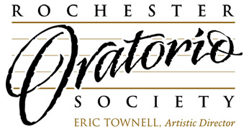

FOR IMMEDIATE RELEASE

ORATORIO SOCIETY PRESENTS CATHEDRAL CLASSICS

(Rochester, NY - 3 August 2017) The splendid acoustical space and pipe organ of Asbury First United Methodist Church provide the ideal setting for CATHEDRAL CLASSICS BY REQUEST, closing the Rochester Oratorio Society's 72nd season of concerts, Friday, April 20, 2018, 7:30 P.M. in the church sanctuary at 1050 East Avenue in the Neighborhood of the Arts. Tickets for this concert ($25, $10 for students with ID) are available from the ROS Office at (585) 473-2234 its web site, www.ROSsings.org, or online at http://classics.bpt.me.

In this program designed to highlight the Society's sumptuous sound, well-known and favorite masterworks of the sacred repertoire by French composers Louis Vierne and Maurice Duruflé, both organ virtuosi who wrote beautifully for choir, appear alongside a brilliant "Regina coeli (Queen of Heaven)," by Mozart, and the radiantly austere and ecstatic "Totus tuus," by Polish composer, Henryk Gorecki, written for St. John Paul II. The ROS is joined by special guests, the Rochester East High School Choir, under the direction of Jodi Zajkowski.

The Rochester Oratorio Society, the region’s premier large mixed chorus for adults, presents 4-6 performances annually and presents the international vocal competition, CLASSICAL IDOL, each spring. Information about the ROS and its productions may be found at www.ROSsings.org or by calling the office at (585) 473-2234.

For more information:
Dennis Rosenbaum, Arts Administrator
drosenbaum@ROSsings.org
1050 East Avenue, Rochester, NY 14607
(585) 473-2234
www.ROSsings.org

# # #

