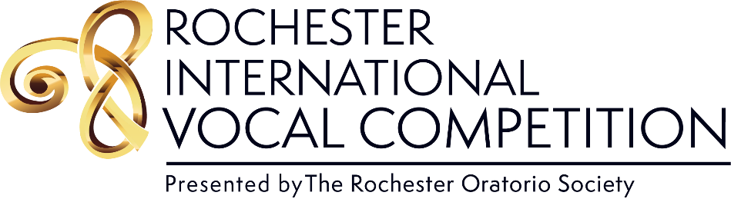

2023 RIVC Celebration
Join us for a multimedia celebration of rising stars. Be there as young artists perform thrilling renditions of the most moving classics of opera, art song, and oratorio live in-person and broadcast from around the world. Participate in this one-of-a-kind evening of music by voting for your favorite performance.
Details and tickets at
rossings.org/RIVC
May 19, 2023 | 7:00 P.M.
First Unitarian Church of Rochester
Ticket sales and donations benefit the Rochester Oratorio Society, the region’s premier choral ensemble, providing community education and live choral music of the highest quality.

